Title of the Abstract
First Author¹*, Second Author², Third Author¹, Fourth Author¹
¹Chair of Energy Systems, TUM School of Engineering and Design, Technical University Munich, Germany
²Institute, Country
*Corresponding author: Author@tum.de

Please use this template for your abstract. The abstract should be longer than 250 words, but must not exceed two A4 pages including all references and figures/tables. The document can then be uploaded in the following formats: DOC, DOCX. Please make sure that the file size remains under 5 MB.
It is possible to use figures (see Fig. 1) or equations as shown here in eq. (1):
$a^{2}=b^{2}+c^{2}$ (1)
Furthermore, references can also be added. [1,2]

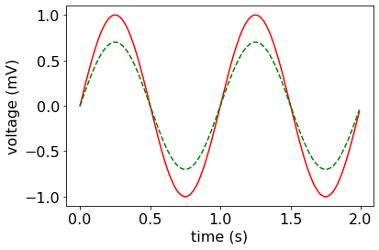
Figure 1: Caption

We look forward to receiving your abstracts.

References
[1] V. Dieterich, N. Wein, H. Spliethoff et al., “Performance Requirements of Membrane Reactors for the Application in Renewable Methanol Synthesis: A Techno‐Economic Assessment,” Advanced Sustainable Systems, vol. 6, no. 12, 2022.
[2] H. Spliethoff, Power Generation from Solid Fuels, Springer Berlin, Berlin, 2013.

